## Question 1

1. Sub-sampling the image changes the image resolution, since for each sub-sampling ratio, we skip pixels in both dimensions: x and y direction, based on the ratio. Figures 1 to 4 show the results obtained for each sub-sampling ratio. In case of subsampling in 2:1, the x-dimension is sub-sampled by 2 :1 ratio, while y-dimension hasn’t been sub-sampled, giving the image the stretched look as shown in Figure 1. For case of subsampling 4:1, both dimensions were subsample by 2:1 ratio giving result shown in Figure 2. For case of sub-sampling the image to a ratio of 8:1, the x-dimension is subsampled by 4:1 ratio, while y-dimension was sub-sampled by 2:1 ratio giving image shown in Figure 3. Finally, for case of sub-sampling image by 16:1 ratio, both dimensions are sub-sampled by 4:1 to 1 ratio, greatly decreasing image resolution, as shown in Figure 4. The MATLAB code to achieve sub-sampling is shown in Figure 30 in Appendix.



Figure 1: Sub-sampling 2:1



Figure 2: Sub-sampling 4:1



Figure 3: Sub-sampling 8:1



Figure 4: Sub-sampling 16:1

1. Figures 5 to 8 show the results obtained via quantization. As can be seen, 1 and 2 bit quantization gives false contours, because intensity of image is just represented by 2 values instead of 255 values in 1 bit quantization, and 4 values instead of 255 values in 2 bit quantization. The script used to achieve quantization can be seen in Figure 31 in Appendix.



Figure 5: 1 bit quantization



Figure 6: 2 bit quantization



Figure 7: 4 bit quantization



Figure 8: 6 bit quantization

1. It was observed that the perceived image quality differed greatly when having SNR as -30, -10, 0, 10 and 30 dB. Larger SNR’s such as 40dB, 30dB, 25dB, 20dB and 10dB result in much better perceived image quality, while lower SNR values decrease perceived image quality as noise is equal, in case of 0dB, l if not more than the signal, in cases of -10dB and -30dB. The resulting image in these cases are shown in figures 9, 10, 11, 12 and 13 respectively. The script used to add Gaussian noise can be seen in Figure 32 in Appendix.



Figure 9: Gaussian noise with SNR = -30dB



Figure 10: Gaussian noise with SNR = -10dB



Figure 11: Gaussian noise with SNR = 0dB



Figure 12: Gaussian noise with SNR = 10dB



Figure 13: Gaussian noise with SNR = 30dB

1. The resulting image obtained by corrupting the pixels with i.i.d noise for impulse probability 0.1, 1, 5 and 10 percent is shown from figures 14 to 18 respectively. To calculate the SNR, the Pnoise was calculated by squaring each entry in the noise matrix and summing the result. Pimage was calculated in a similar manner, and the two powers divided by each other to arrive at the SNR. Log10 of this result was taken and then multiplied by 10 to arrive at SNR in dB. For 0.1% probability, the SNR = 30.81 dB. For 1% probability, SNR = 21.07 dB. For 5% probability, SNR = 14.17 dB. For 10% probability, SNR = 11.16 dB. Figure 33 in appendix shows the script used to add impulsive noise.



Figure 14: probability iid = 0.1%



Figure 15: probability iid = 1%



Figure 16: probability iid = 5%



Figure 17: probability iid = 10%

1. The Gaussian noise seems to add black pixels as noise in the image, whereas the i.i.d. one seems to add white impulsive pixels.

## Question 2

1. It was observed that with higher values of N, the blurring intensity increases. Figure 18 shows the image blurred with N = 20 and figure 19 shows the image blur with N = 5. Figure 34 in Appendix shows how the images were blurred.



Figure 18: blur image with N = 20



Figure 19: blur image with N = 5

1. For this test, the SNR for Gaussian blur was set as 10dB and the resulting image is given in Figure 12. Figure 20 shows the result obtained when applying a 3 by 3 low pass filter on the noisy image. Figure 21 shows the result obtained by applying 5 by 5 low pass filter on the image. The filter was applied in frequency domain by taking FFT of the original image as well as the filter and convolving them. The results are obtained by then taking the inverse FFT of the convolution. Figure 35 shows the script used to reduce Gaussian noise.



Figure 20: 3x3 low pass filter on image with Gaussian noise. SNR = 10dB



Figure 21: 5x5 low pass filter on image with Gaussian noise. SNR = 10dB

1. For this experiment, the probability of i.i.d. impulse was set as 10%, where the resulting noisy image is shown in figure 17. The result obtained by applying 3 by 3 low pass filter on this noisy image is shown in figure 22 and the result of 5 by 5 filter is shown in figure 23. This approach works because it blurs out the i.i.d. impulse created on the image, therefore fixing the noise. Figure 36 shows the script used to reduce impulsive noise.



Figure 22: 3x3 low pass filter on image with iid noise. Piid = 10%



Figure 23: 5x5 low pass filter on image with iid noise. Piid = 10%

1. The result obtained by applying the 3 by 3 median filter is shown in figure 24, while figure 26 shows the result of 5 by 5 median filter. This filter takes the median of every 3-by-3 subsection of the image and therefore, it would average out the i.i.d. impulse encountered in most cases. Thus, median filter works in removing most of the impulsive noise. Figure 37 shows the script used to reduce impulsive noise using Median filter.



Figure 24: 3x3 Median Filter



Figure 25: 5x5 median filter

1. Applying the high pass filter on the image gives the resulting image of Figure 26. This seems to have passed the high intensity pixels in the image, therefore giving a highlight effect. Figure 38 shows the script used to pass the image through high pass filter



Figure 26: High pass filter result

## Question 3

1. Figure 27 shows the 2-D fft plot result on the original image. **Frequencies up till 500Hz are present?? SHorouq!!!! Taha, I don’t understand these plots!!!**

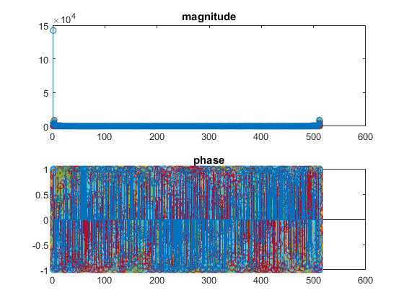

Figure 27: 2D FFT plot of Mandrill image

d) The magnitude of the image was taken by first taking the FFT of the mandrill image and then taking the absolute of the result, as shown in Figure 28. This shows how many different frequencies or intensities are present in the image.



Figure 28: Magnitude of 2D Fourier transform of Mandrill image

e) The frequency of the image was taken by first computing the FFT of the Lena image and then dividing the result with the magnitude. This gave the resulting image as shown in Figure 29. This shows the relative positioning of the each intensity at the image.



Figure 29: Phase 2D Fourier transform of Lena image

## Question 4:

1. The artificial image of the square is generated on each X,Y where X and Y are the dimensions of the image. The background is set to white by making the 4-bit intensities of R (red color intensity), G (green color intensity) and B (blue color intensity) to 1111. The square is generated using an if statement at X and Y. For a square of side of 30 pixels the intensities at X = 100 to X=130, and at Y= 100 and Y = 140, since VGA supports up to 640x480 Y side has to be multiplied by 1.33 to have a square, are changed to 0000 for R,G, and B for a black square. Using a switch case statements where cases represent switches on board, different sizes of the square are changed by changing X and Y if statement pixel parameters. The Verilog code is shown in **Figure** in Appendix.
2. To move square across the screen, the square produced is moved one pixel in X dimension and one pixel in Y dimension on each positive edge clock cycle. Different speeds are achieved by moving square by more or less pixels in each dimension on each clock cycle. Also, switch case statements are used for different speeds controlled by switched on FPGA board. The Verilog code is shown in **Figure** in Appendix.
3. The moving square in part (b) is made to change color in each second by having a counter that increments on each clock cycle. Since the clock has a frequency of 60 Hz, the counter has to reach 60, equivalent to one second, for the color of square to be changed. For different colors of the rainbow, the intensities R, G and B were changed accordingly. The Verilog code for this part is shown in **Figure** in Appendix.

## Appendix

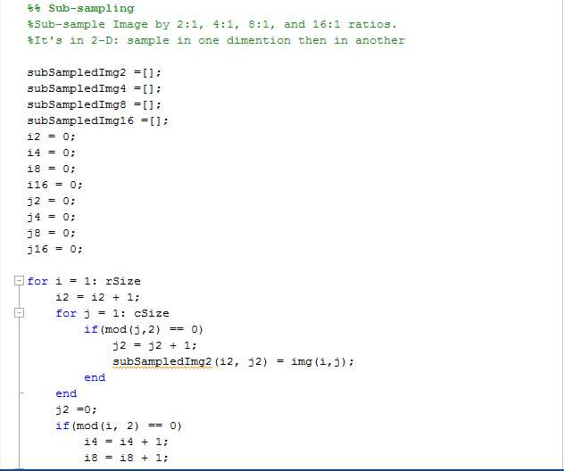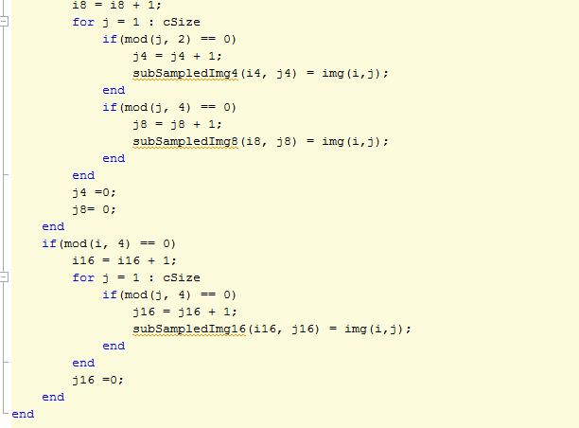

Figure : Sub-sampling algorithm

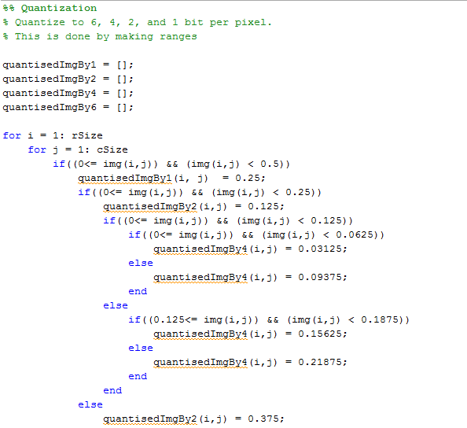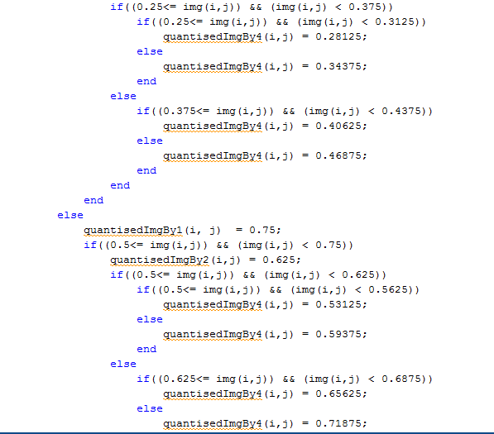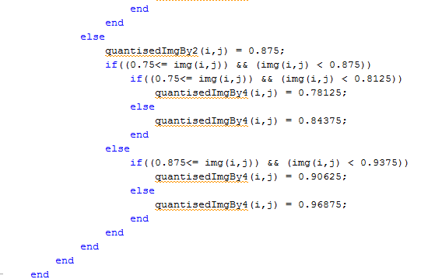

Figure : Quantization of image

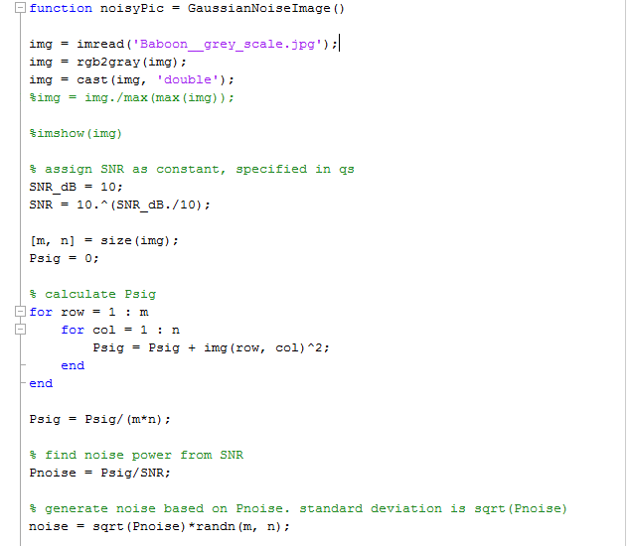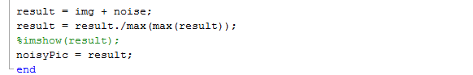

Figure : Gaussian Noise corruption

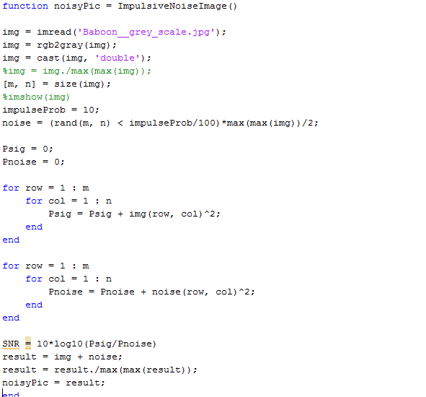

Figure : Impulsive noise corruption

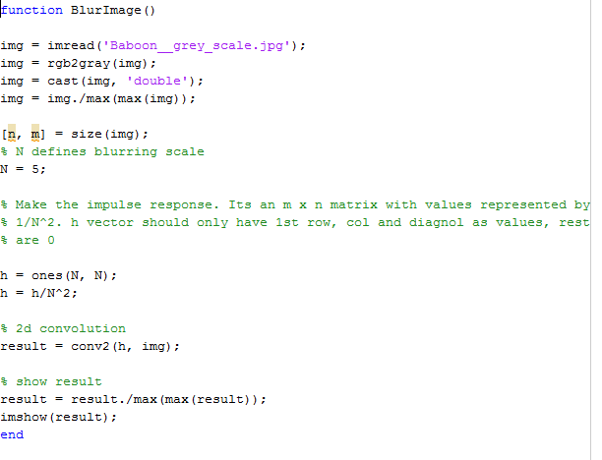

Figure : Blur Image

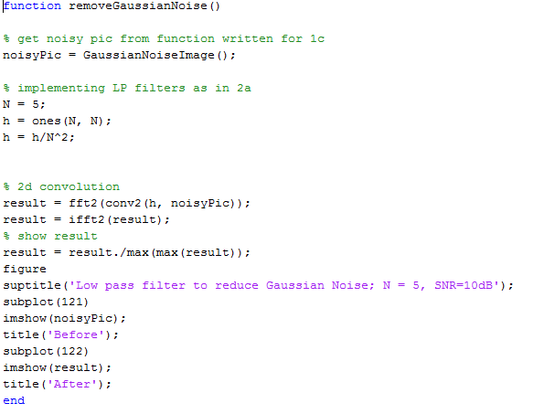

Figure : Remove Gaussian noise from image using low pass filter

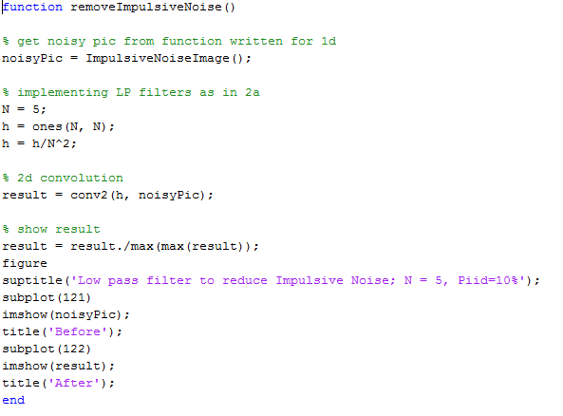

Figure : Remove impulsive noise from image using low pass filter

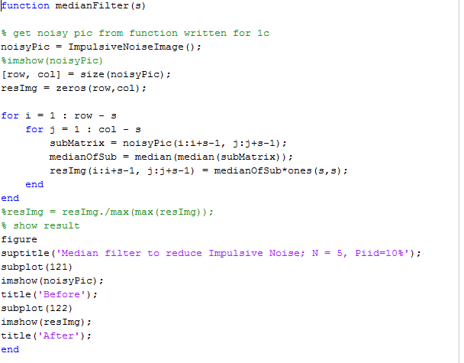

Figure : Remove Impulsive noise using median pass

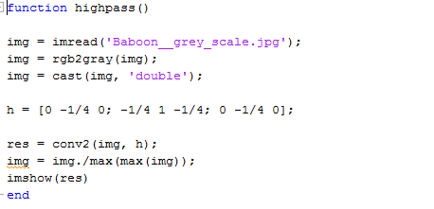

Figure : High pass on image